

**MTC Lighting**

**E-commerce website for lights**

BY Saloni M Darji



**K. S. School of Business Management,**

**MSc in Computer Application and Information Technology,**

**Gujarat University.**

**Summer Internship Project**

**M.Sc. (CA & IT)**

**MTC Lighting**

**Submitted by : - Saloni M Darji 2155094**

**Company Name : - Manav Trading & co.**

**Overview of Contents**

1. **Introduction** 
   1. Organization Profile
   2. System Details
      1. Existing System
      2. Proposed System
   3. Scope of System
   4. Objectives
2. **Proposed System Requirement Gathering**
   1. Stakeholder of System
   2. Requirement Gathering Technique Used
   3. Consolidated List of Requirement
   4. Project Definition
3. **System Management and Planning**
   1. Feasibility Study
      1. Technical
      2. Economic
      3. Operational
   2. Hardware Software Requirement
   3. System Planning
      1. Work Breakdown Structure
      2. Gantt Chart
   4. Process Model
4. **System Analysis and Design**
   1. UML (Unified Modeling Language) / DFD
   2. System Flow Diagram
   3. Data Dictionary
   4. User Interface
   5. System Navigation
   6. Front End Design
   7. Report Design
5. **Summary**
   1. Assumption
   2. Limitation
   3. Conclusion
   4. Future Scope

**Chapter 1**

**Introduction**

* 1. **Organization Profile**

**Name:** MANAV TRADING & CO.

**Area of work: Manav Trading & Co.**  are a reliable Manufacturer, Distributor, Supplier, Trading Company, Wholesaler of LED Products etc. Manav Trading & Co. is one of Trade India's verified and trusted sellers providing satisfactory range of LED Products at affordable prices.

**Established** in **2013**

**Address:** 10M17 /118, Near Azad Apartment /2, Behind. Sahajanand College, Ambawadi, Ahmedabad, Gujarat, 380015, India

**Contact:** 08068345613

* 1. **System Details**

The system is mainly used to buy different types of lights. It also has backend panel(CMS) to maintain order, products, payments, users , etc.

* + 1. Existing System
* It does not have existing system.
  + 1. Proposed System
* In proposed system I have provided features like online payment, email verification, notification ,order placing ,dynamic content, product search , chart analysis in backend etc.
  1. **Scope of System**

**Frontend:**

* User can search for the product that they want to purchase.
* Add product to wishlist or cart after reading reviews.
* Online payment is supported by Razor Pay, which is the most trusted third party gateway for Ecommerce.
* Order history gives update regarding order status. For ex. Pending, in process, dispatched etc.

**Backend:**

* Backend supports multiple Admin.
* Profit/Order analysis will be done by chart based upon last 5 Days.
* Dynamic Add, Update, Delete and view of every attribute will be performed to give clarity.
* Admin Dashboard provide Login feature.
  1. **Objective of System**
* The objective of our system is to provide feasibility to customer and expand customer reach.
* Also it will reduce the cost of maintaining stock and hence profitable growth will be achieved.

**Chapter 2**

**Proposed System Requirement Gathering**

* 1. **Stakeholder of System**
     1. Admin
* Admin can manage all the function and features; he / she can maintain and enhance the profitability.
  + 1. User
* Our users can securely get product simply by ordering from anywhere.
  1. **Requirement Gathering Technique Used**

In requirement gathering we use different types of fact-finding techniques like **Questionnaires** and **Observation.**

**Questionnaires**

**Questionnaires for End-Users**

* Do you face any problem while purchasing things from shop?
  + - Yes
    - No

**Observation**

* We observed that people don’t like to wander , they want all things at one place where they can easily get their things.  
  1. **Consolidated List of Requirement**
* Easily find the product
* Review from who have used the same product
* Security
  1. **Project Definition**

**“MTC Lightings”**

* We observed that lot of time is wasted in travelling to shop, just because people don’t know where to find good things easily, sometimes they end up wasting their valuable time in inquiry to multiple shop or misleading people. We are going to develop the web application (frontend) where anyone can easily find good quality products through our system in less time, at one place.
* We also observed on the seller side that they sometime end up wasting so much time to convince people to buy product. Also it is hard for them to analyze profit-loss scenarios and they face trouble to reach each end user. So this system (backend) will make their life easy and help to expand customer reach and enhance profitability.

**Chapter 3**

**System Management and Planning**

* 1. **Feasibility Study**

The aim to do the feasibility study is to identify or determine whether the system which I am going to develop is financially, technically and operationally feasible or not. The following feasibility studies determine the feasibility of our system.

* + 1. **Technical Feasibility**
* The project is technically feasible because it is made with the Angular framework which is good enough to provide Efficient working flow.
* The system is made using cross-platform technology so same Website will work nicely in mobile Apps also.
  + 1. **Economic Feasibility**
* The economic feasibility is performed really well as the same codebase will work for both platform which leads to cost effective budget.
  + 1. **Operational Feasibility**
* Operational feasibility is also easy, as customer just needs to go on website link and scroll over to get needed product with secured payment.
  1. **Hardware and software requirements**

**Software Configuration:**

* + - Programming Language: JavaScript , Typescript
    - Operating system: windows 7 or later
    - Front end: Angular 7, jquery
    - Back end: Node.js, MySQL
    - Editor: Visual Studio Code
    - Tools: Woo Commerce Template, Razor pay

**Hardware Requirements:**

* Memory: 512 MB Minimum
* Disk Space: 750 MB Minimum free disk space
  1. **System planning**
     1. Work Breakdown Structure
     2. Gantt Chart

|  |  |  |  |  |  |  |  |  |  |
| --- | --- | --- | --- | --- | --- | --- | --- | --- | --- |
| **Activities** | | **July** | | **Aug** | | **Sep** | | **Oct** | **Nov** |
| Introduction | Organization profile |  |  |  | |  | |  |  |
| System Details |
| Scope |
| Objectives |
| Requirement Gathering | Stack holders |  |  |  | |  | |  |  |
| Techniques |
| Consolidated list of requirements |
| Project definition |
| Management and planning | Feasibility study |  |  |  | |  |  |  |  |
| Hardware and software requirements |
| System Planning |
| Process Model |
| Analysis and designing | UML Diagram |  | |  |  |  | |  |  |
| System Flow Diagram |
| Data dictionary |
| User Interface |
| System navigation |
| Summary | Assumption |  | |  | |  |  |  |  |
| Limitation |
| Conclusion |
| Future Scope |
| Documentation | |  | |  | |  | |  |  |

* 1. **Process Model**

As new requirements arise in future, increment model is best model which suits our system. In every increment we can add new feature based on the analysis of previous release and user feedback. The main functionalities will be delivered in the first release of system. This model is best when there are small amount of employees are available. The system can be developed prior to the deadline.

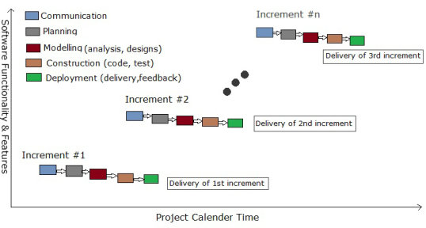

**Chapter 4**

**System Analysis and Design**

* 1. **UML (Unified Modeling Language)** 
     1. Use Case Diagrams

**User**

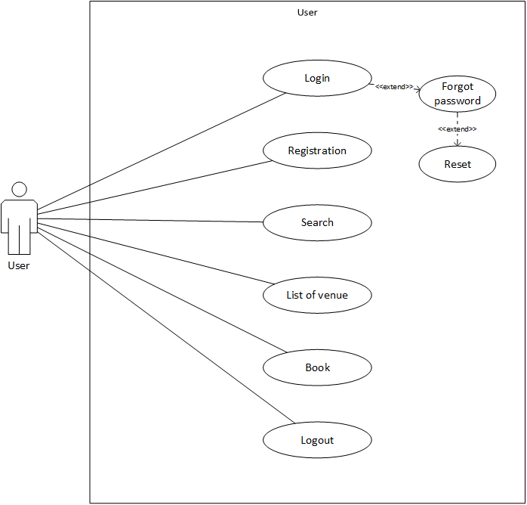

**Venue Owner**

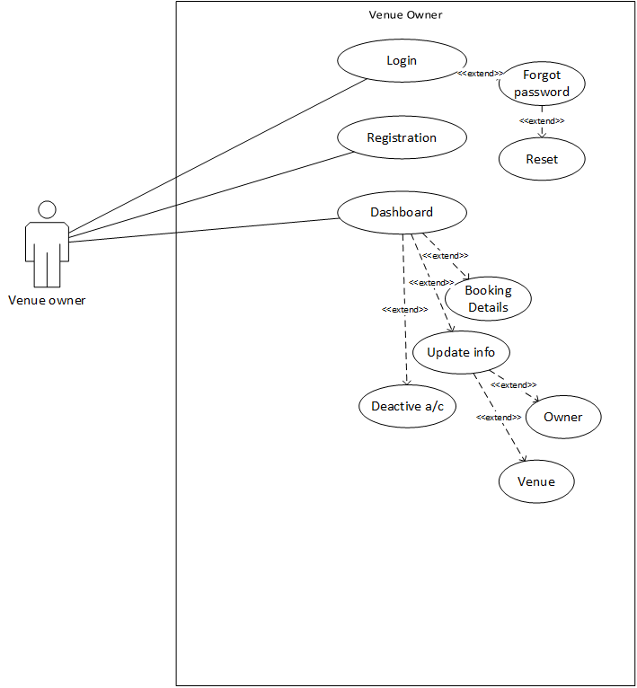

**Admin**

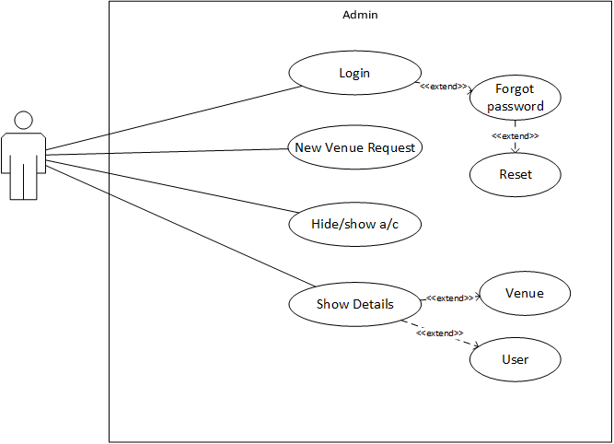

* + 1. Class Diagrams

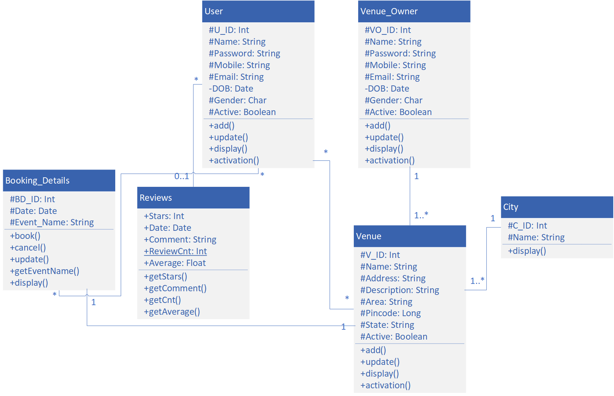

* + 1. Activity Diagrams

**User**

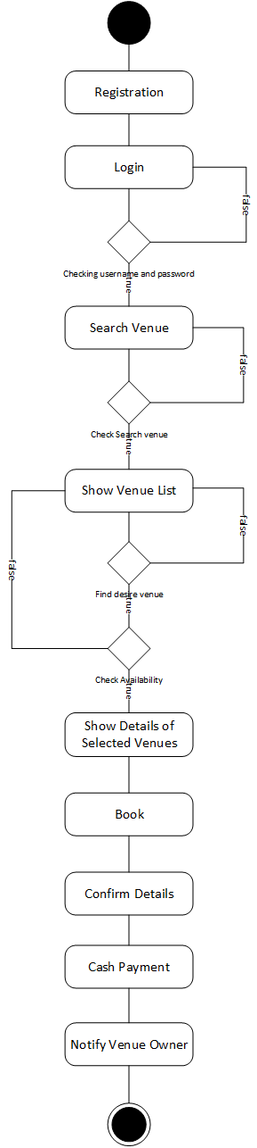

**Venue Owner**

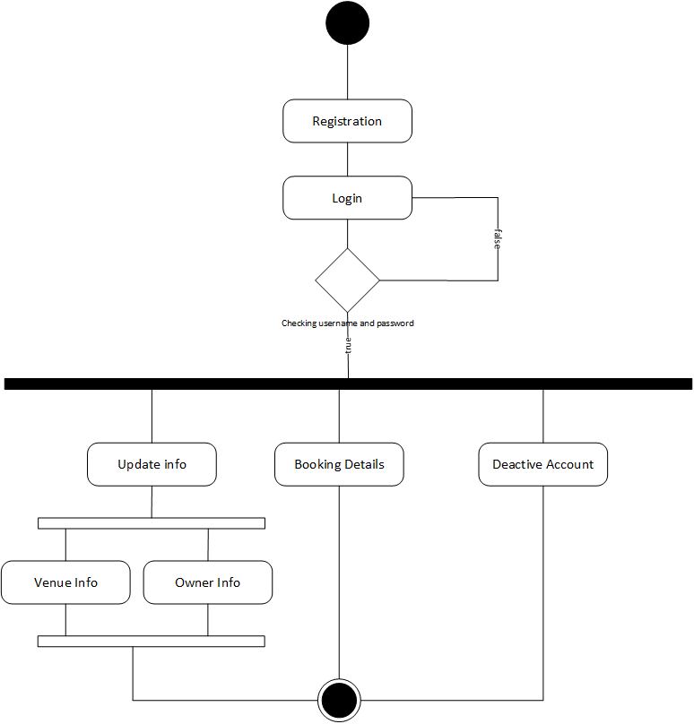

**Admin**

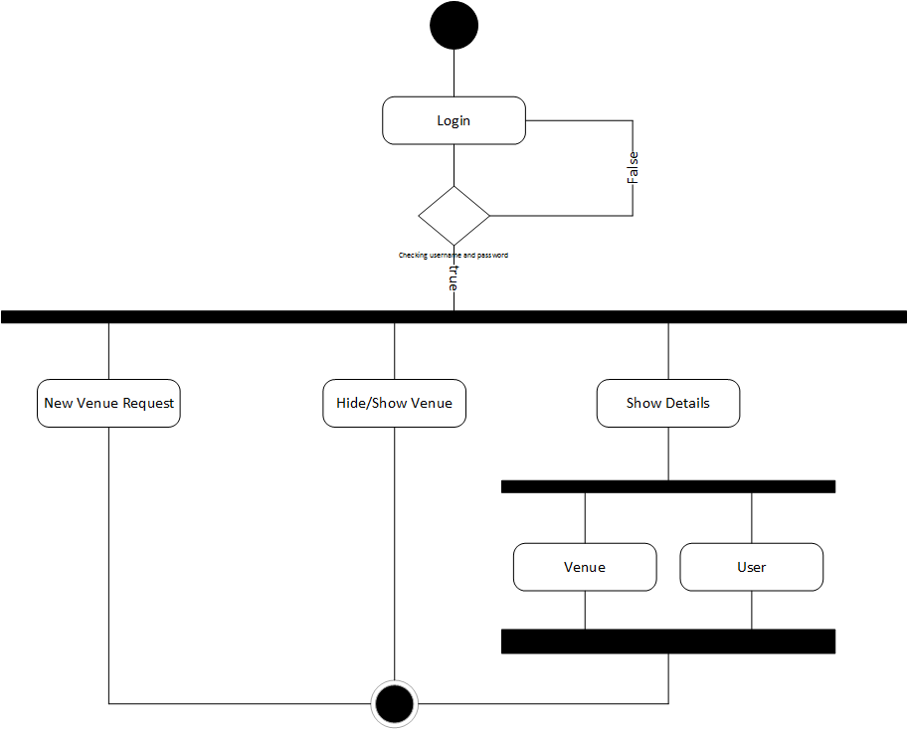

4.1.4 Sequence Diagram

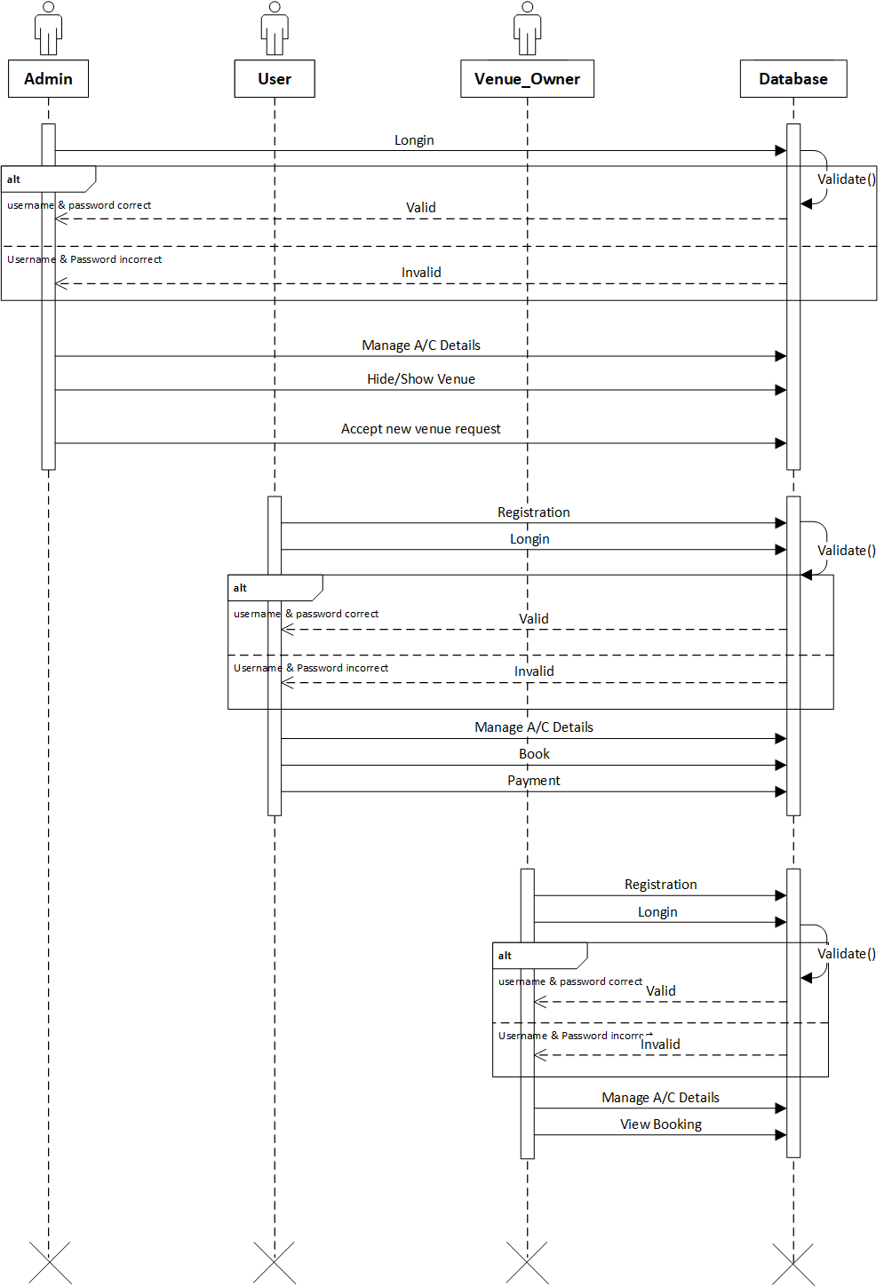

* 1. **System Flow Diagram**

**User**

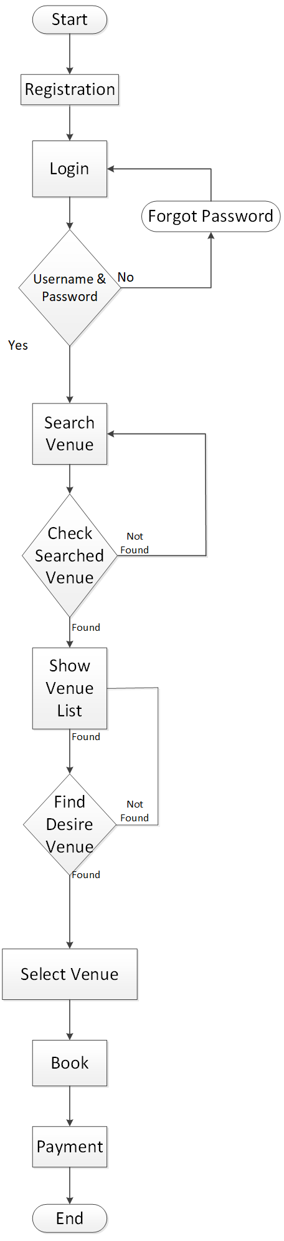

**Venue Owner**

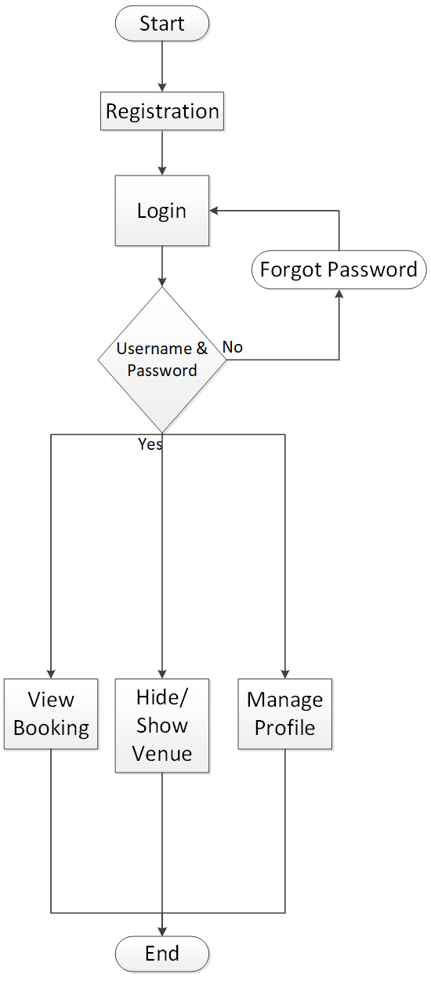

**Admin**

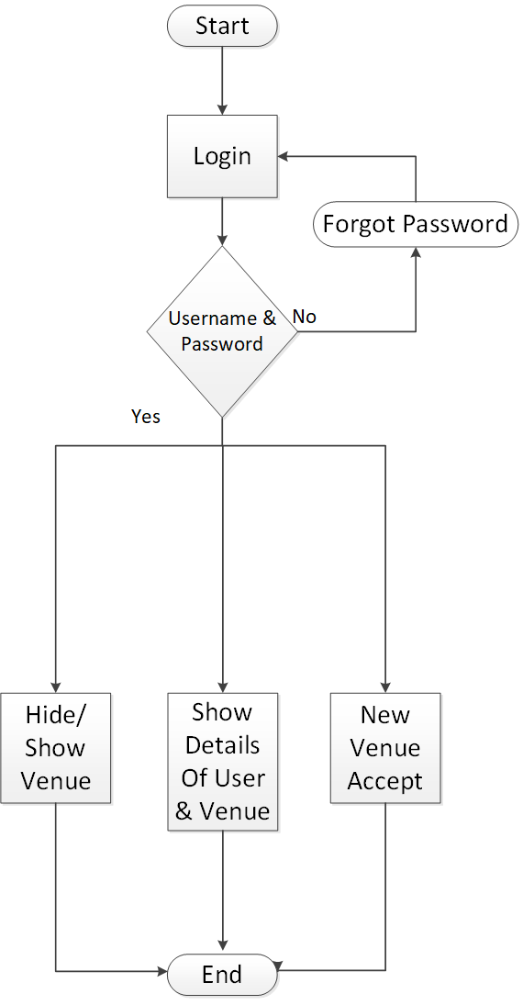

* 1. **Data Dictionary**

User

|  |  |  |  |  |  |
| --- | --- | --- | --- | --- | --- |
| No | Field name | Data type | Size | Constraints | Description |
| 1 | U_ID | Auto |  | Primary key | Stores primary key of user data |
| 2 | Fname | Varchar | 15 | Not null | Stores first name of user |
| 3 | Lname | Varchar | 15 | Not null | Stores last name of user |
| 4 | Password | Varchar | 15 | Not null | Stores user's password |
| 5 | Mobile | Varchar | 15 | Not null | Stores mobile number of user |
| 6 | Email | Varchar | 30 | Not null | Stores email id of user |
| 7 | DOB | Date |  | Not null | Stores date of birth |

Venue Owner

|  |  |  |  |  |  |
| --- | --- | --- | --- | --- | --- |
| No | Field name | Data type | Size | Constraints | Description |
| 1 | VO_ID | Auto |  | Primary Key | Stores primary key of user data |
| 2 | Fname | Varchar | 15 | Not null | Stores first name of user |
| 3 | Lname | Varchar | 15 | Not null | Stores last name of user |
| 4 | Password | Varchar | 15 | Not null | Stores user's password |
| 5 | Mobile | Varchar | 15 | Not null | Stores mobile number of user |
| 6 | Email | Varchar | 30 | Not null | Stores email id of user |
| 7 | DOB | Date |  | Not null | Stores date of birth |
| 8 | Active | Boolean |  | Not null | Venue owner is Active or inactive |

Admin

|  |  |  |  |  |  |
| --- | --- | --- | --- | --- | --- |
| No | Field Name | Data type | Size | Constraints | Description |
| 1 | A_ID | Auto |  | Primary key | Stores primary key of Admin data |
| 2 | Password | Varchar | 15 | Not null | Stores Admin's password |
| 3 | Mobile | Varchar | 15 | Not null | Stores mobile number of user |
| 4 | Email | Varchar | 30 | Not null | Stores email id of user |
| 5 | DOB | Date |  | Not null | Stores date of birth |

Venue_list

|  |  |  |  |  |  |
| --- | --- | --- | --- | --- | --- |
| No | Field Name | Data type | Size | Constraints | Description |
| 1 | V_ID | Auto |  | Primary Key | Stores primary key of venue list |
| 2 | VO_ID | Int |  | Foreign Key | Stores primary key of venue owner |
| 3 | Name | Varchar | 25 | Not null | Stores Name of venue |
| 4 | Address | Varchar | 100 | Not null | Stores address of venue |
| 5 | Images |  |  |  |  |
| 6 | Description | Varchar | 200 | Null | Stores description about venue |
| 7 | Area | Varchar | 20 | Not null | Stores area of venue |
| 8 | Pincode | Varchar | 6 | Not null | Stores pin code of venue |
| 9 | C_ID | Int |  | Foreign Key | Stores Foreign key of City database |
| 10 | State | Varchar | 20 | Not null | Stores state of venue |
| 11 | Total_Review | Int |  | Null | Stores total number of reviews |
| 12 | Avg_Review | Double |  | Null | Stores average rating out of 5 |
| 13 | Contact | Varchar | 10 | Not null | Stores contact number of venue |
| 14 | Active | Boolean |  | Not null | Venue owner is Active or inactive |
| 15 | Rate | Double |  | Not null | Stores rate |
| 16 | Type | Varchar | 20 | Not null | Stores type of venue (i.e., Party Plot, Banquet hall etc.) |

City

|  |  |  |  |  |  |
| --- | --- | --- | --- | --- | --- |
| No | Field name | Data type | Size | Constraint | Description |
| 1 | C_ID | Auto |  | Primary Key | Stores Primary Key of City |
| 2 | Name | Varchar | 20 | Not null | Stores name of city |

Booking Details

|  |  |  |  |  |  |
| --- | --- | --- | --- | --- | --- |
| No | Field Name | Datatype | Size | Constraints | Description |
| 1 | BD_ID | Auto |  | Primary Key | Stores Primary key of Booking details |
| 1 | V_ID | Int |  | Foreign Key | Stores Primary key of Venue List |
| 2 | U_ID | Int |  | Foreign Key | Stores Primary key of User |
| 3 | Date | Date |  | Not Null | Date & Time of booking |
| 4 | Event_name | Varchar | 15 | Not Null | Name of event |
| 5 | Cancellation | Boolean |  | Not Null | By default false |
| 6 | Payment_Type | Boolean |  | Not null | True=online payment |

Review_Mngt

|  |  |  |  |  |  |
| --- | --- | --- | --- | --- | --- |
| No | Field name | Data type | Size | Constraint | Description |
| 1 | U_ID | Int |  | Foreign Key | Stores Foreign of User |
| 2 | V_ID | Int |  | Foreign Key | Stores Foreign of Venue |
| 3 | Stars | Numeric | 1 | Null | Stores stars out of 5 |
| 4 | Date | Date & Time |  | Not null | Stores date & time of review |
| 5 | Comment | Varchar | 100 | Null | Stores comment |

Cancellation

|  |  |  |  |  |  |
| --- | --- | --- | --- | --- | --- |
| No | Field name | Data type | Size | Constraint | Description |
| 1 | Cancellation_ID | Int |  | Primary key | Stores primary key for table |
| 2 | U_ID | Int |  | Foreign key | Stores foreign key for user table |
| 3 | V_ID | Int |  | Foreign key | Stores foreign key for Venue list table |
| 4 | Date | Date & Time |  | Not null | Stores cancellation date and time |

* 1. **User Interface**

Frontend Website

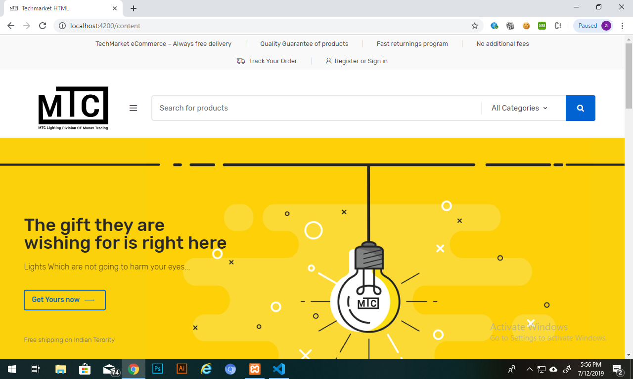

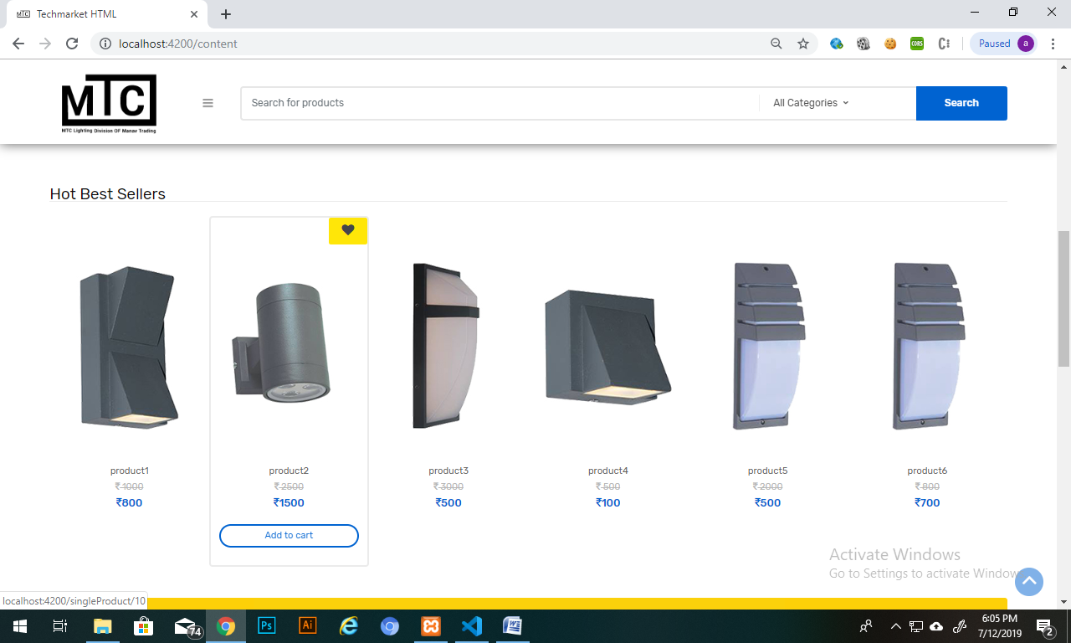

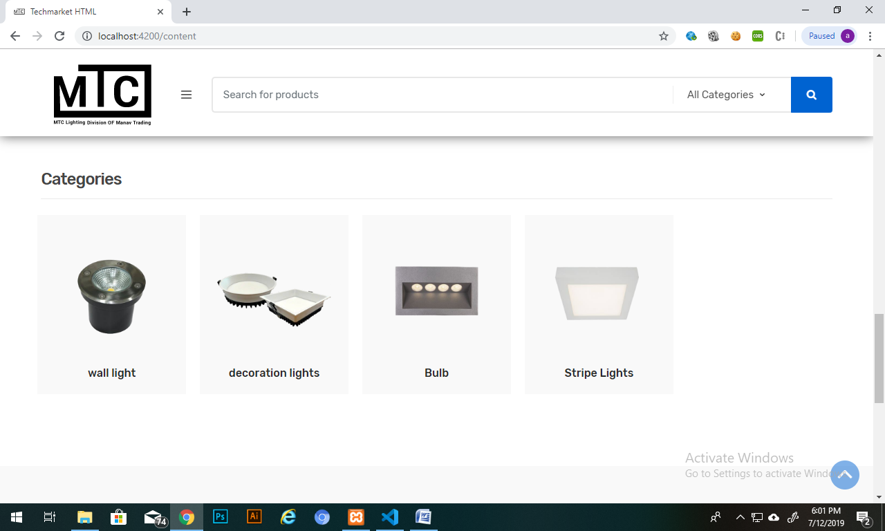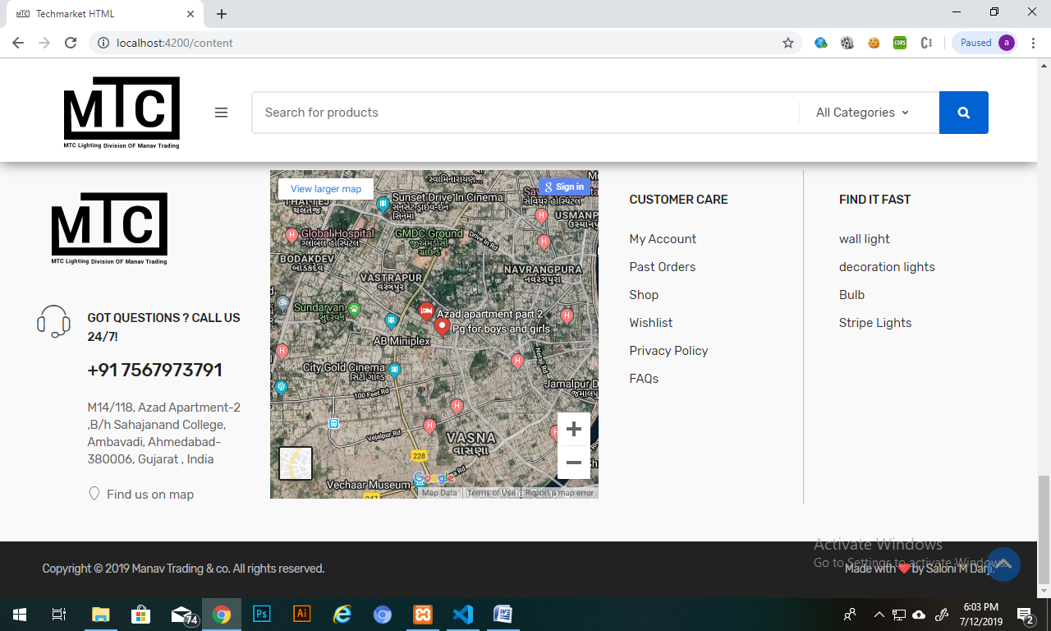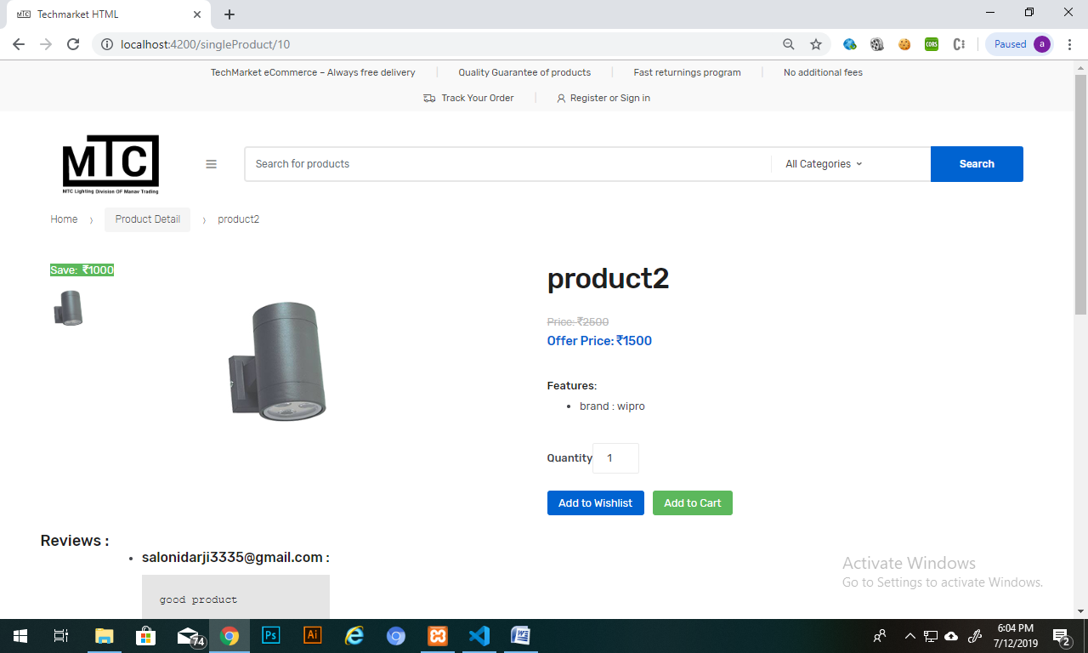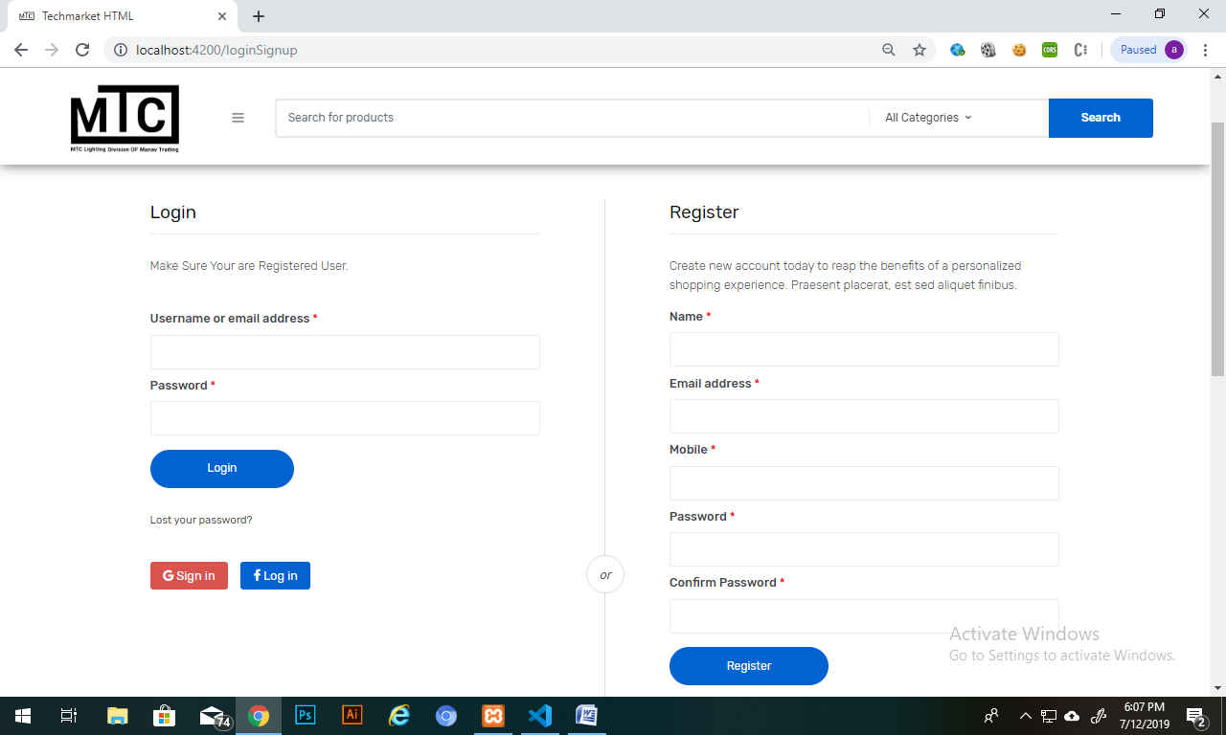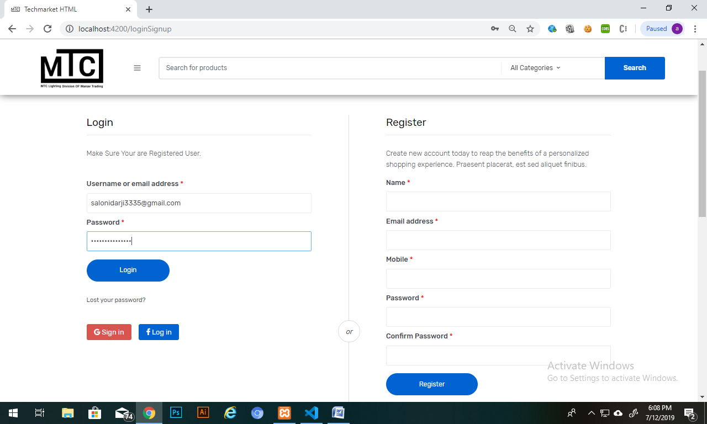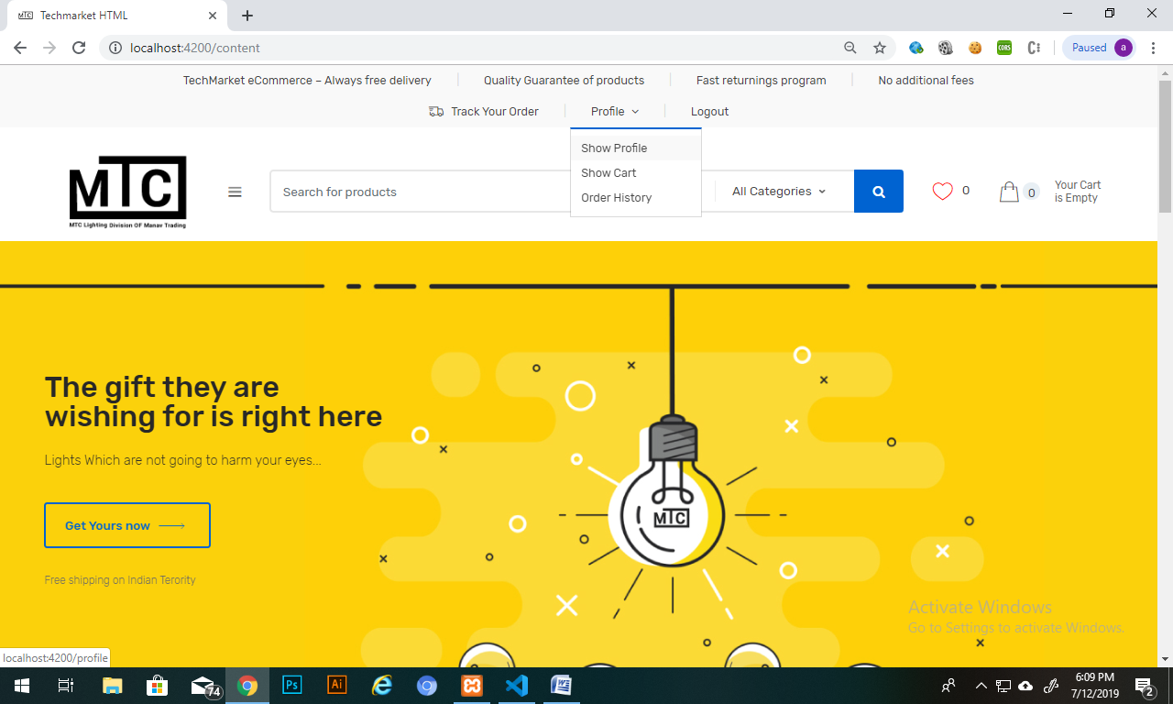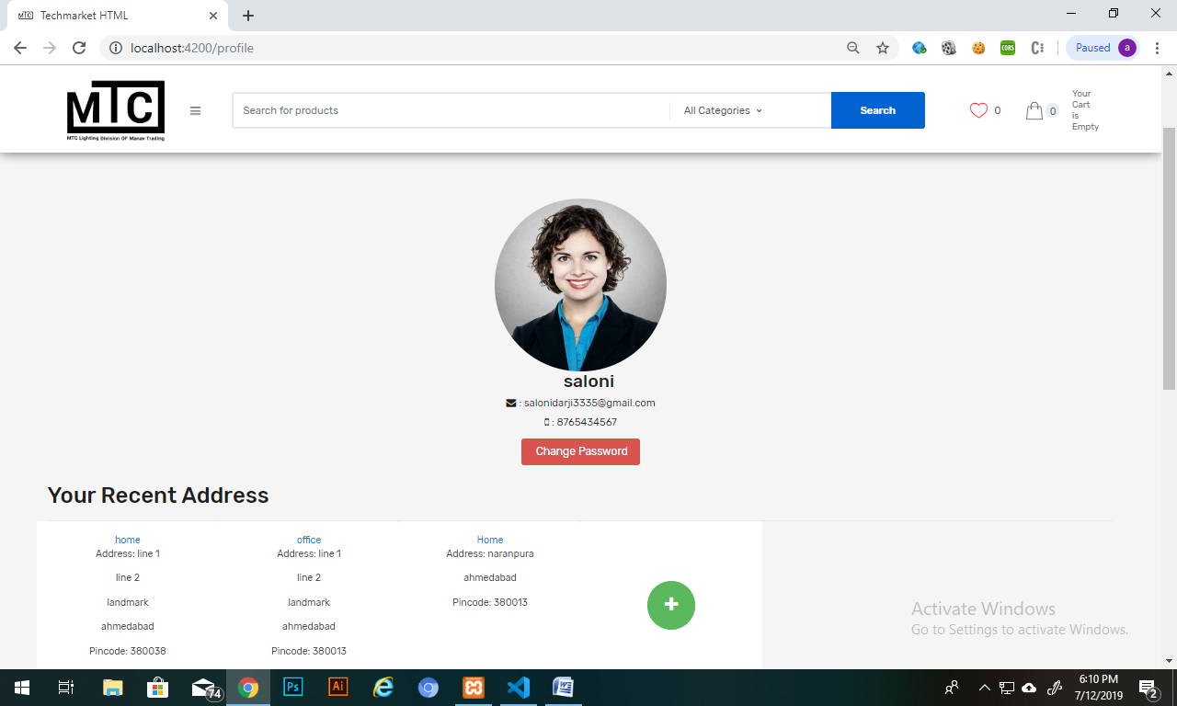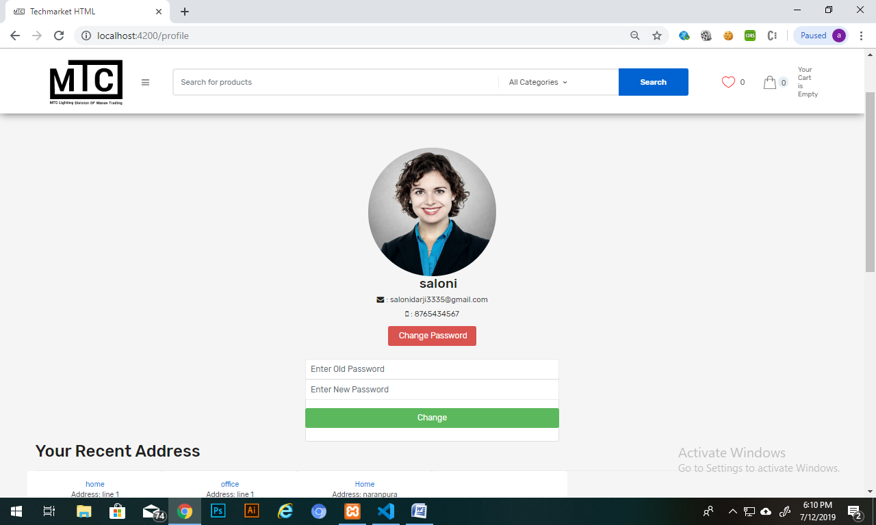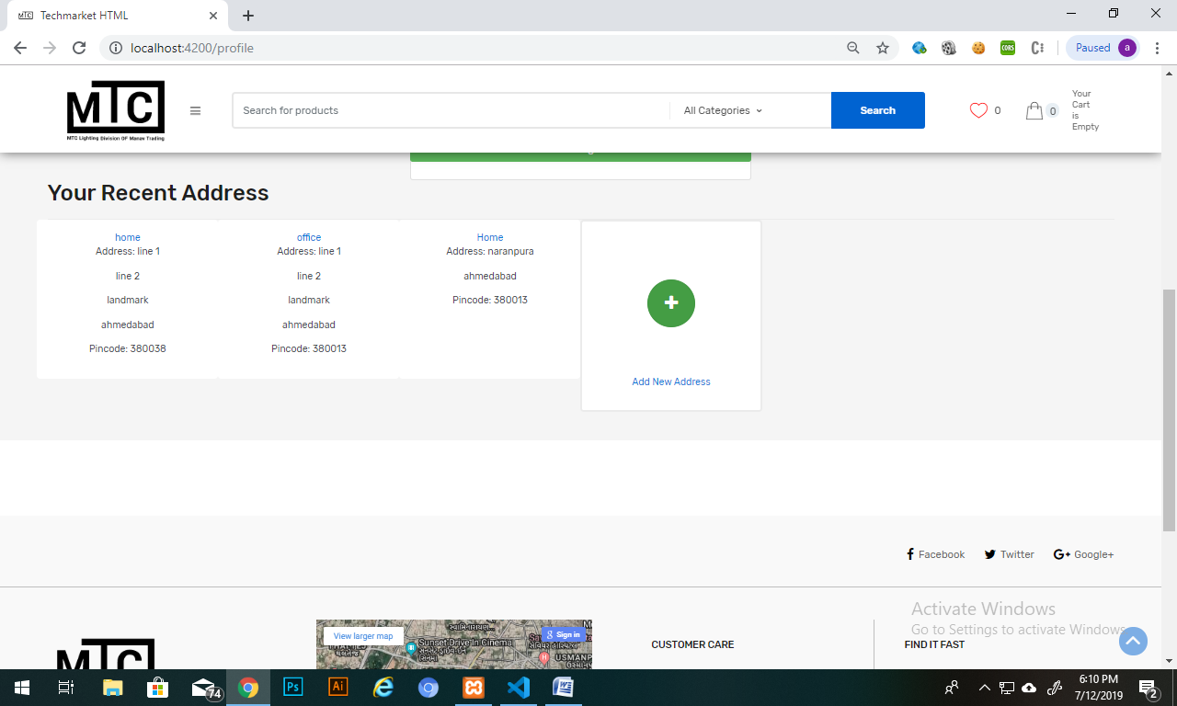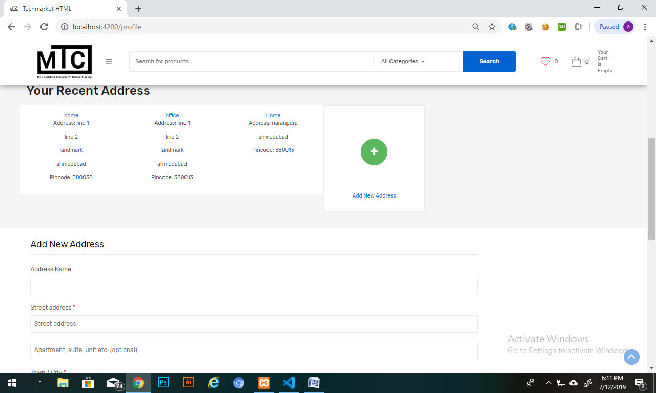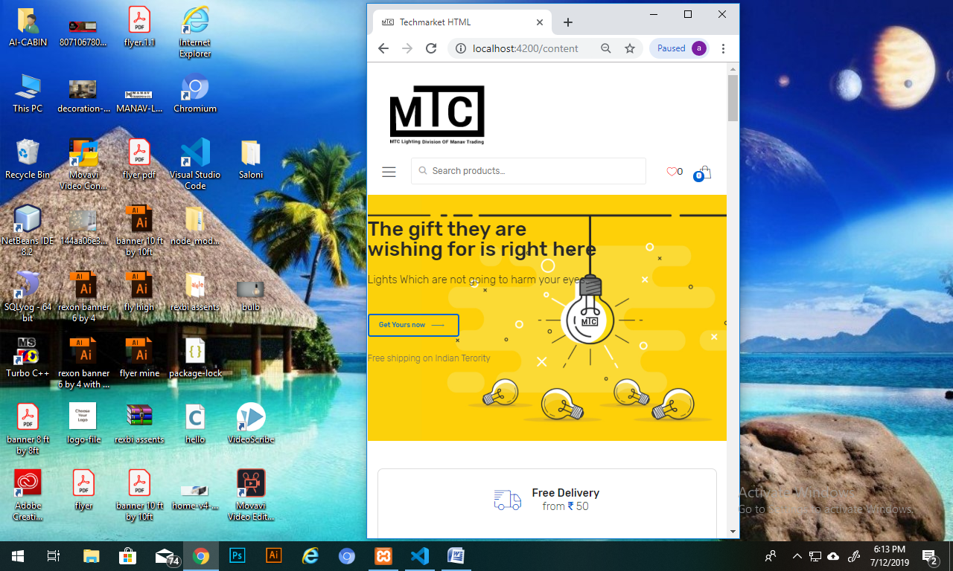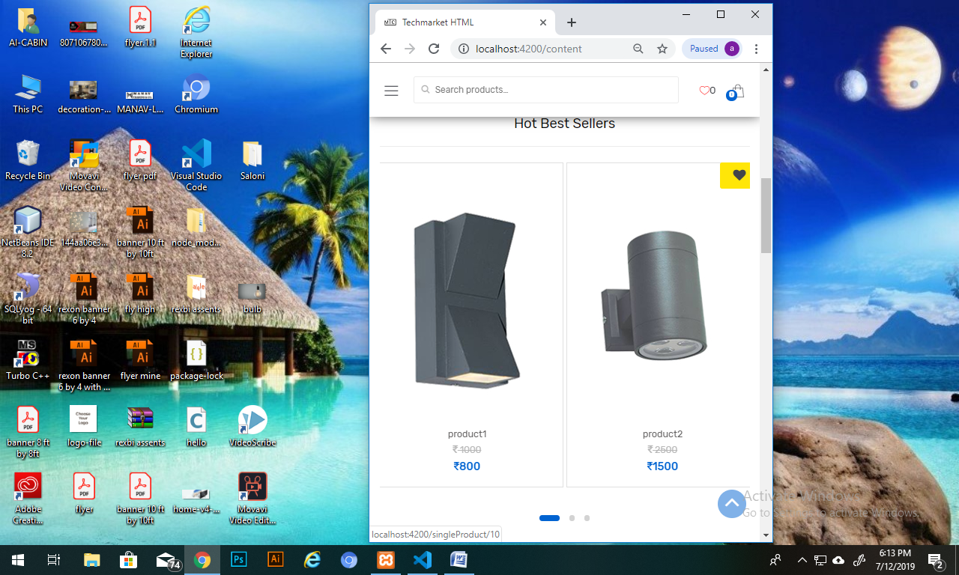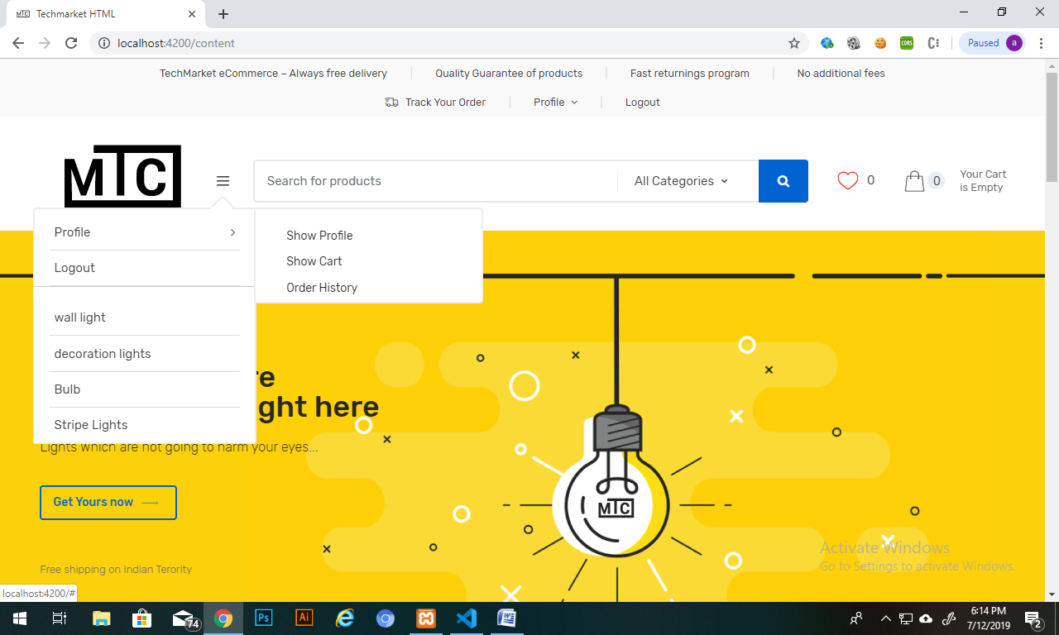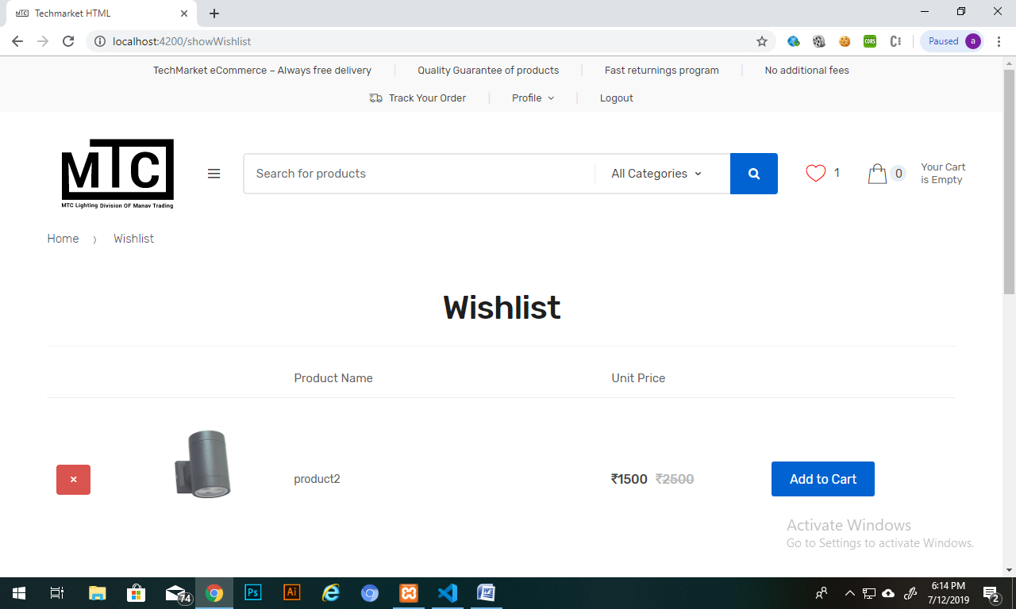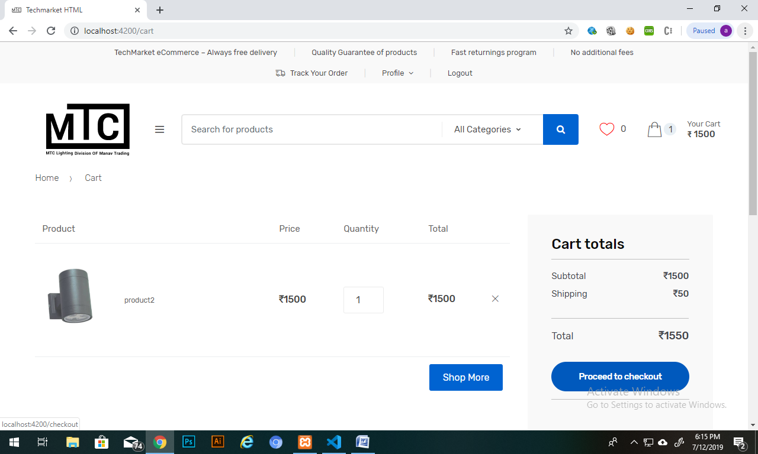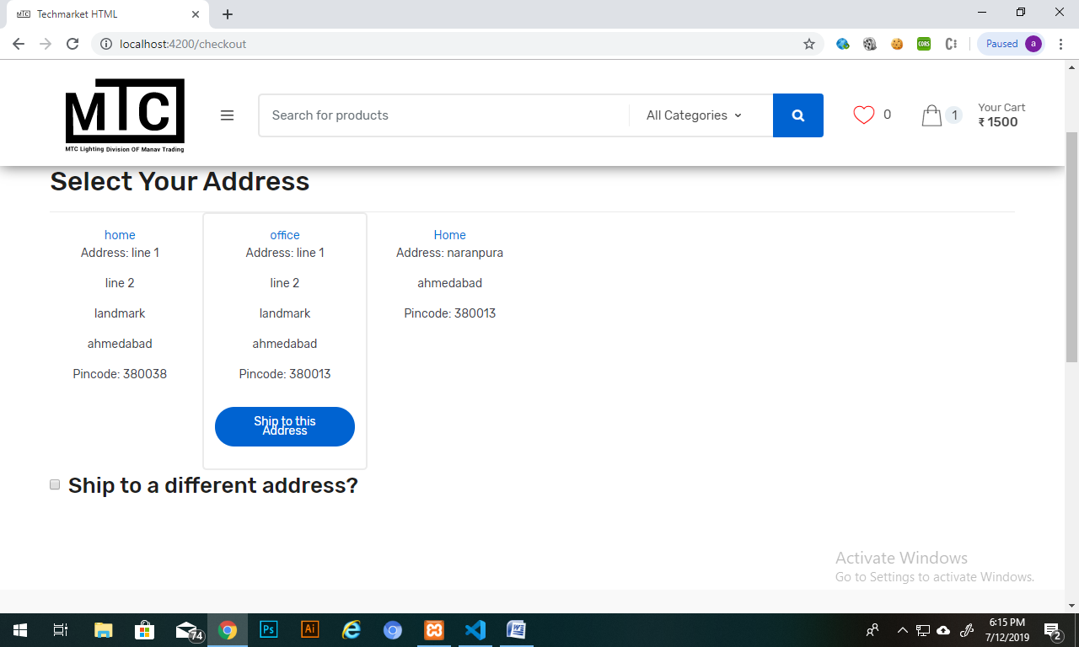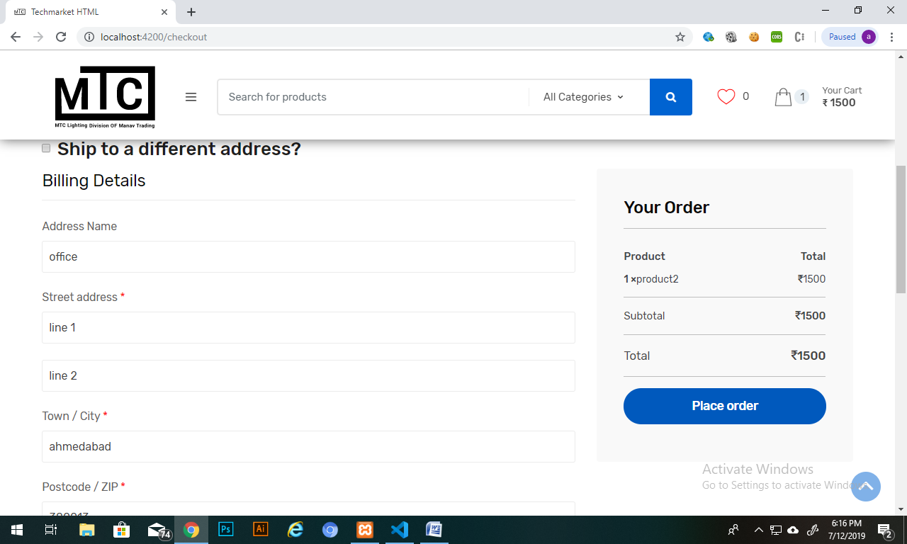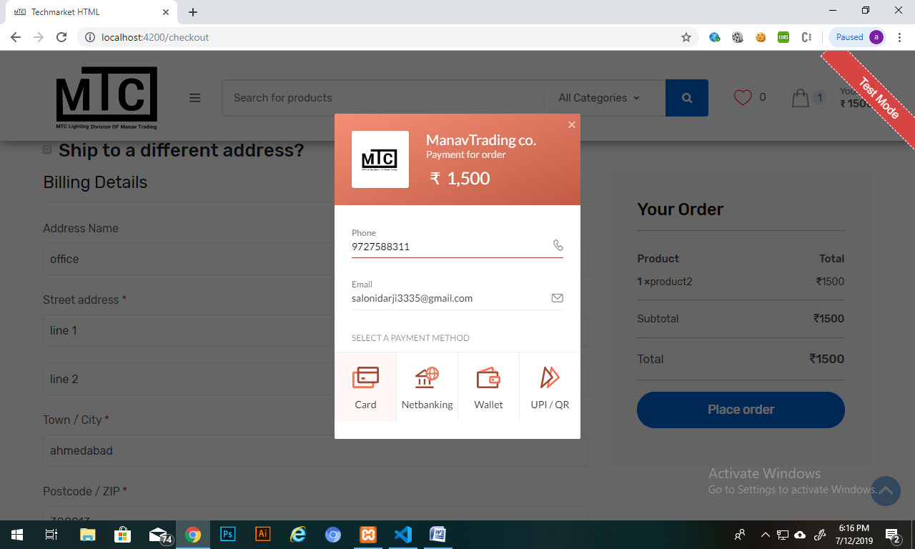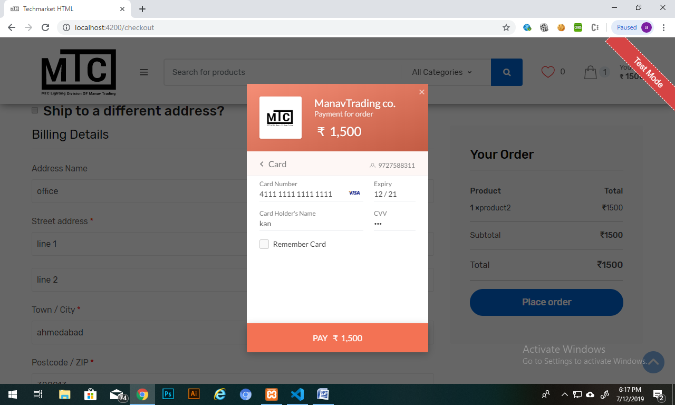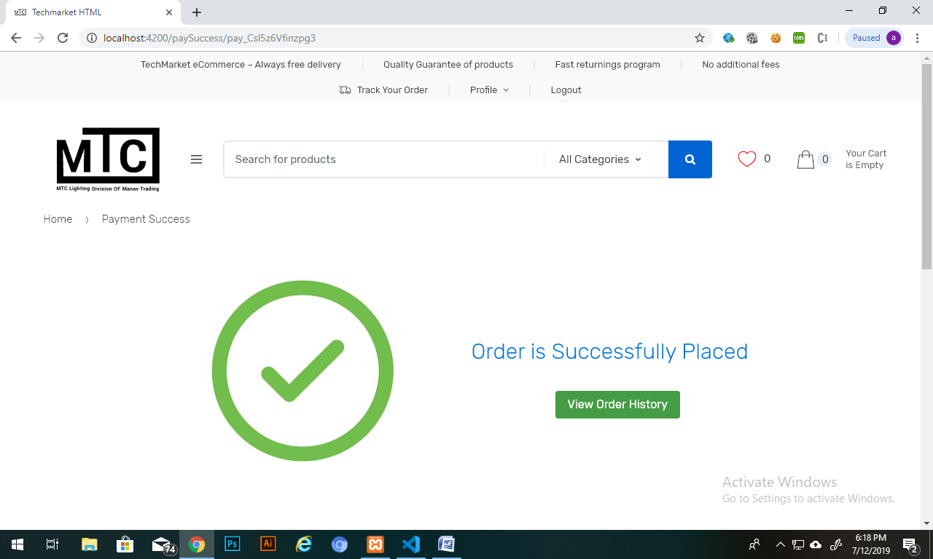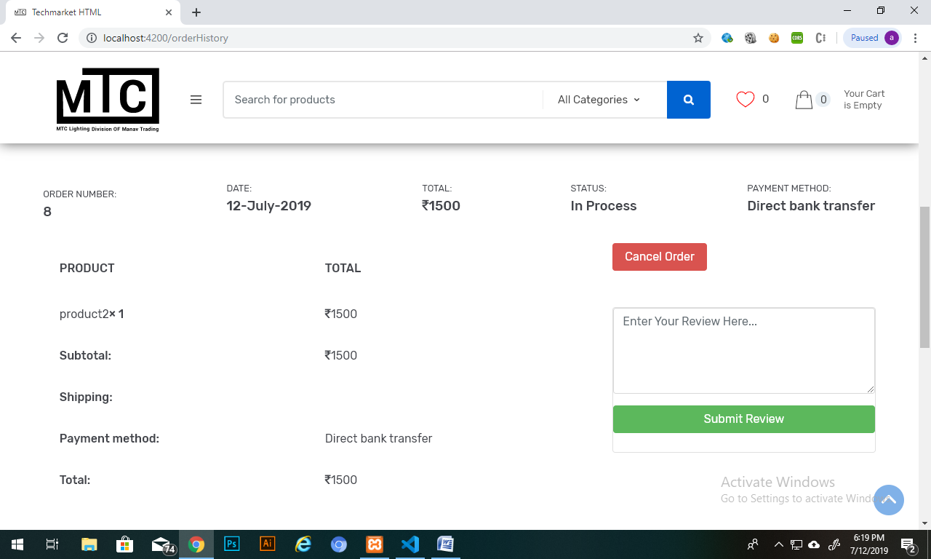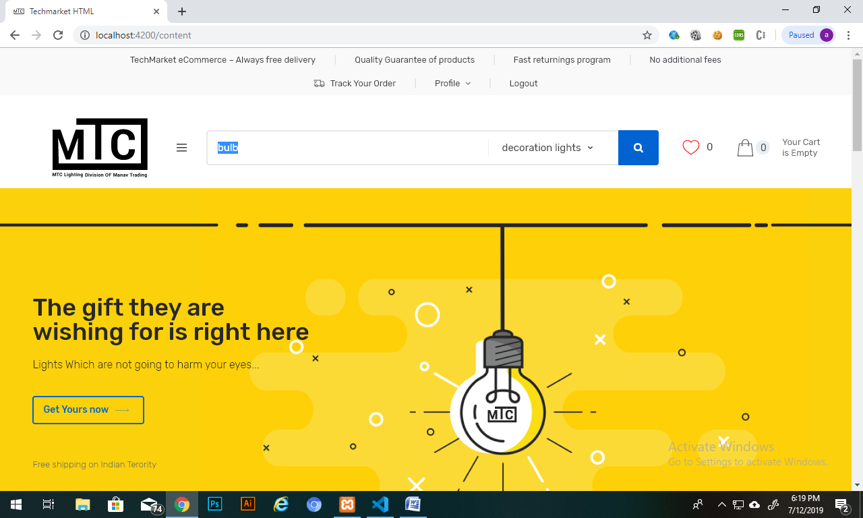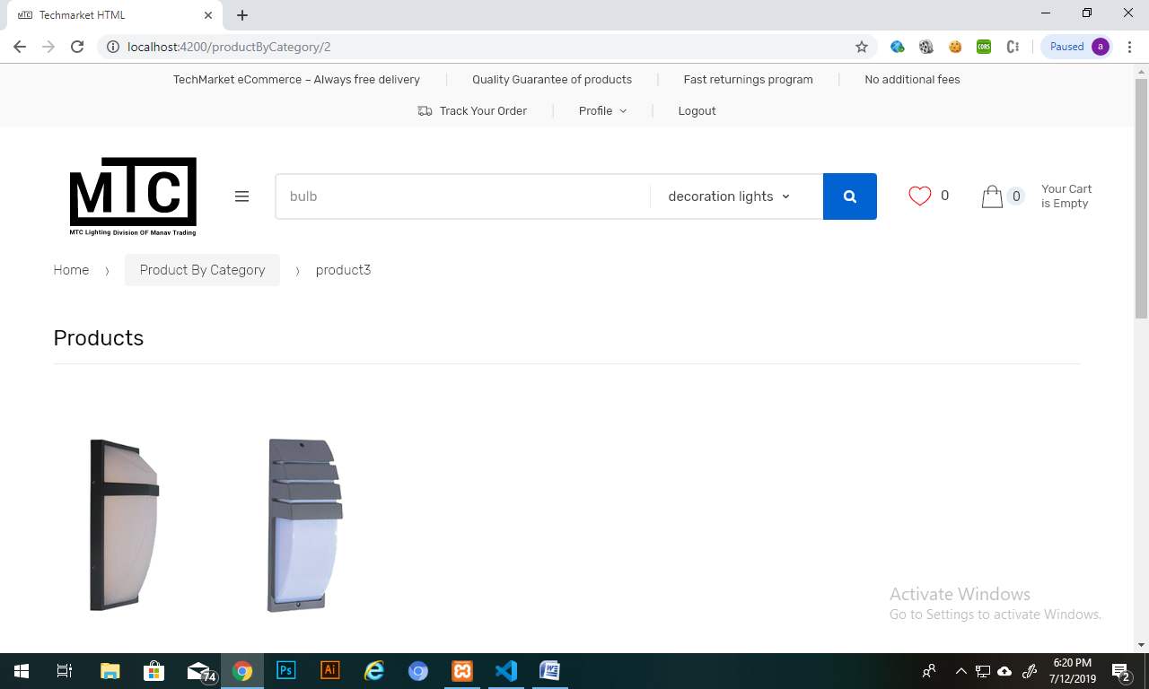

Backend Admin Panel:

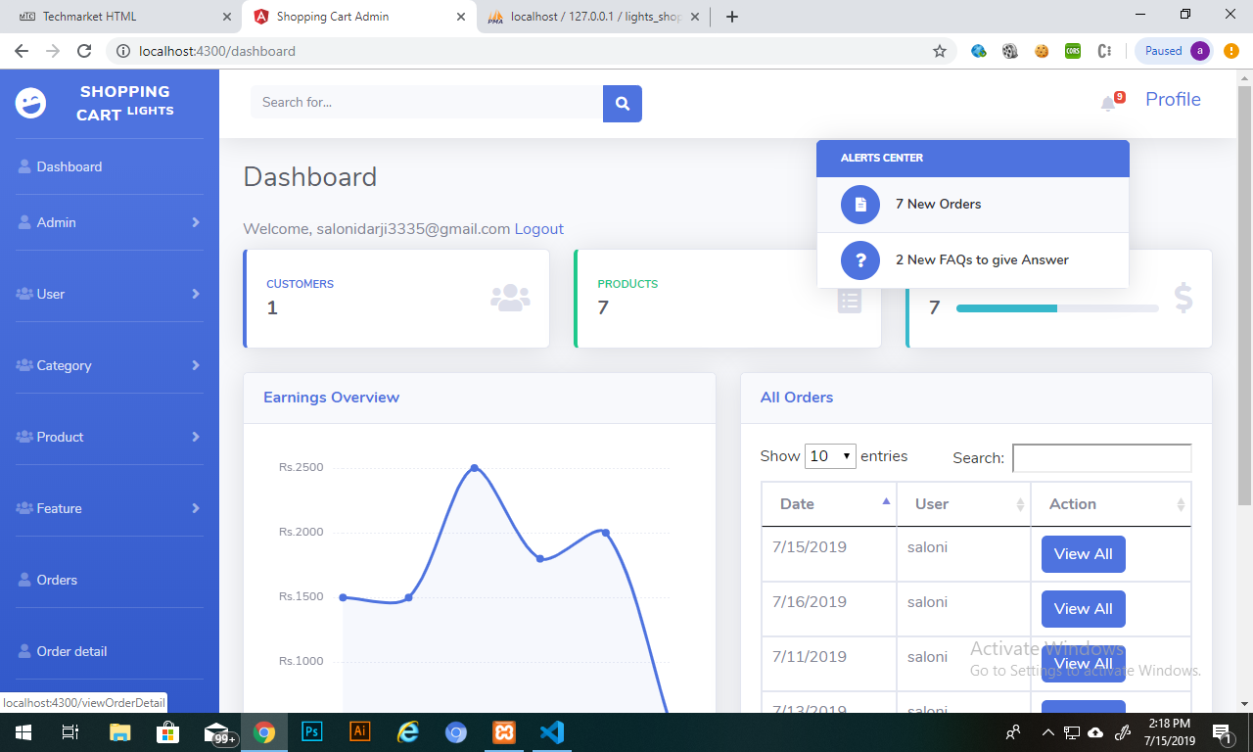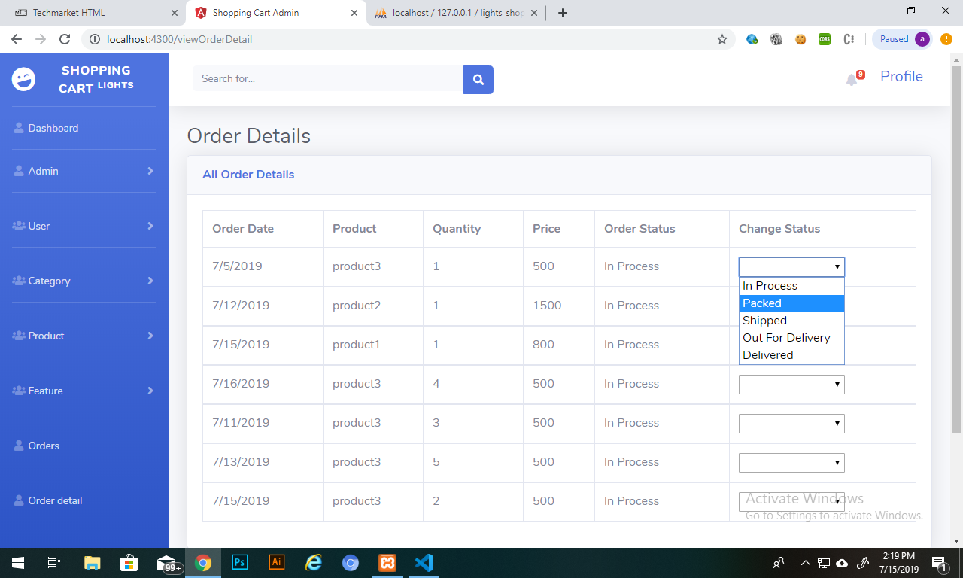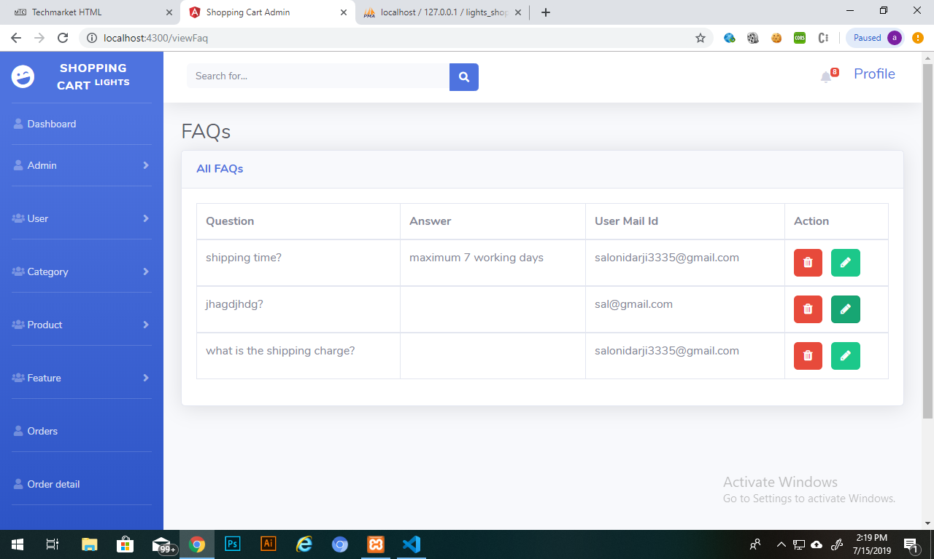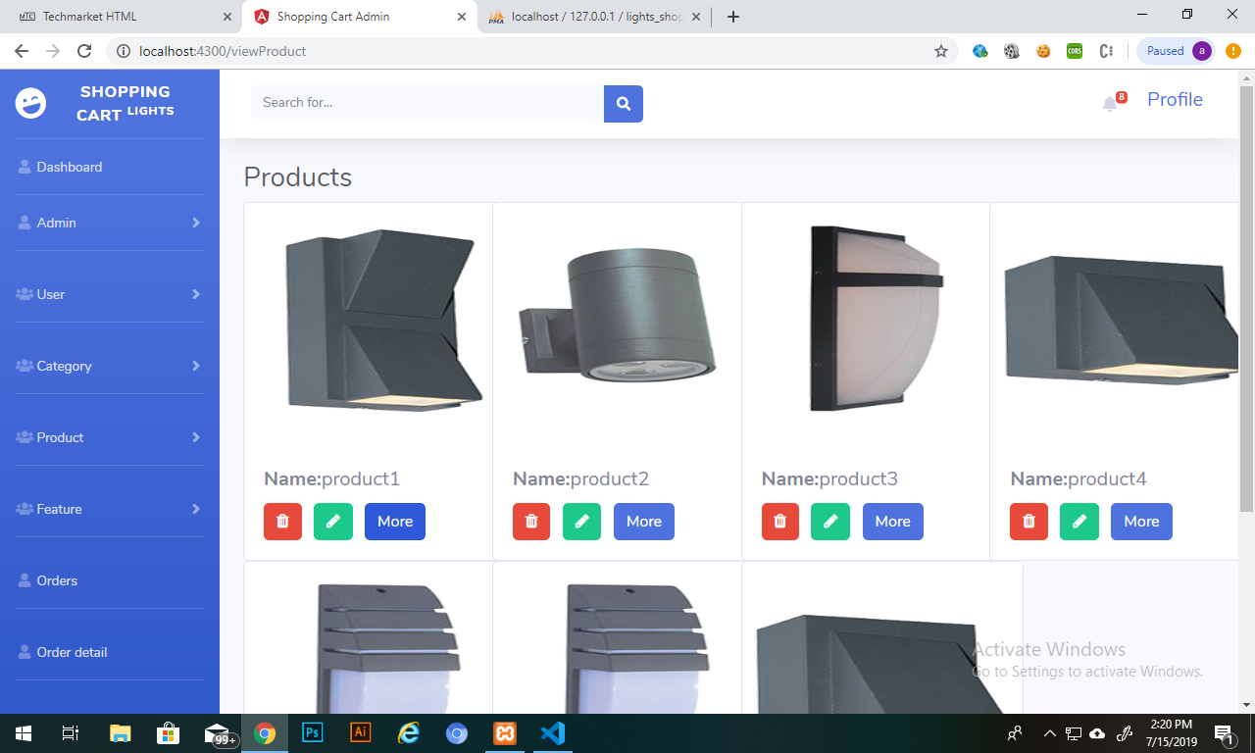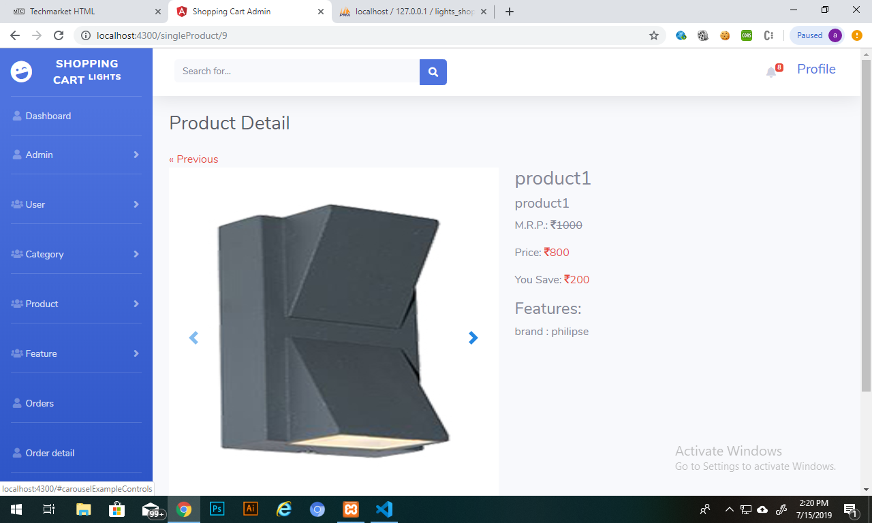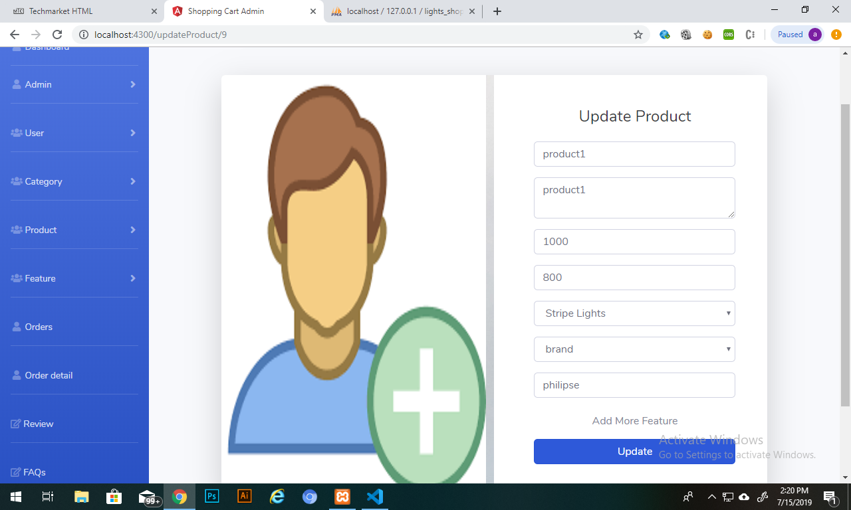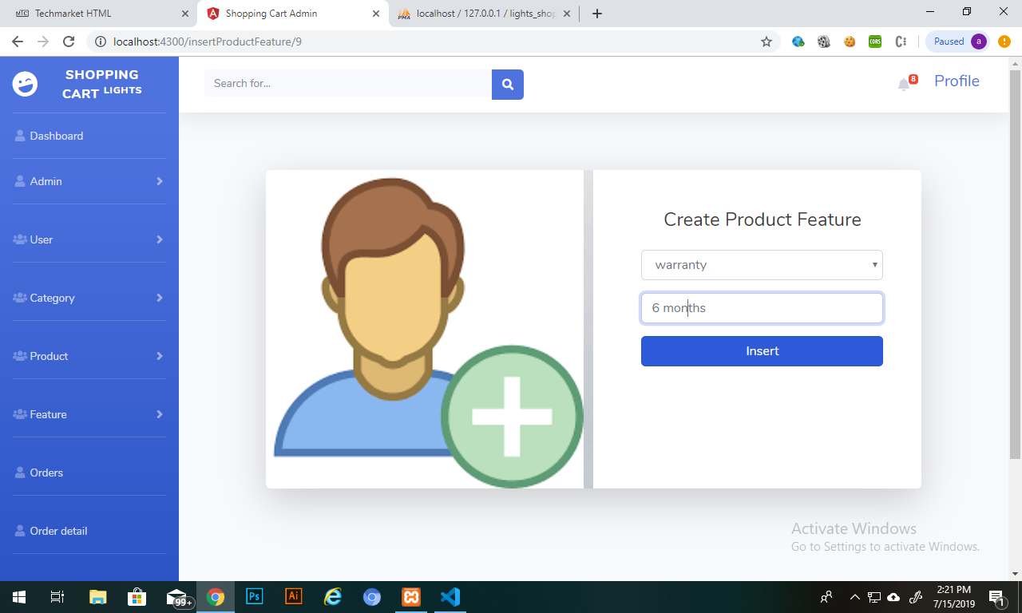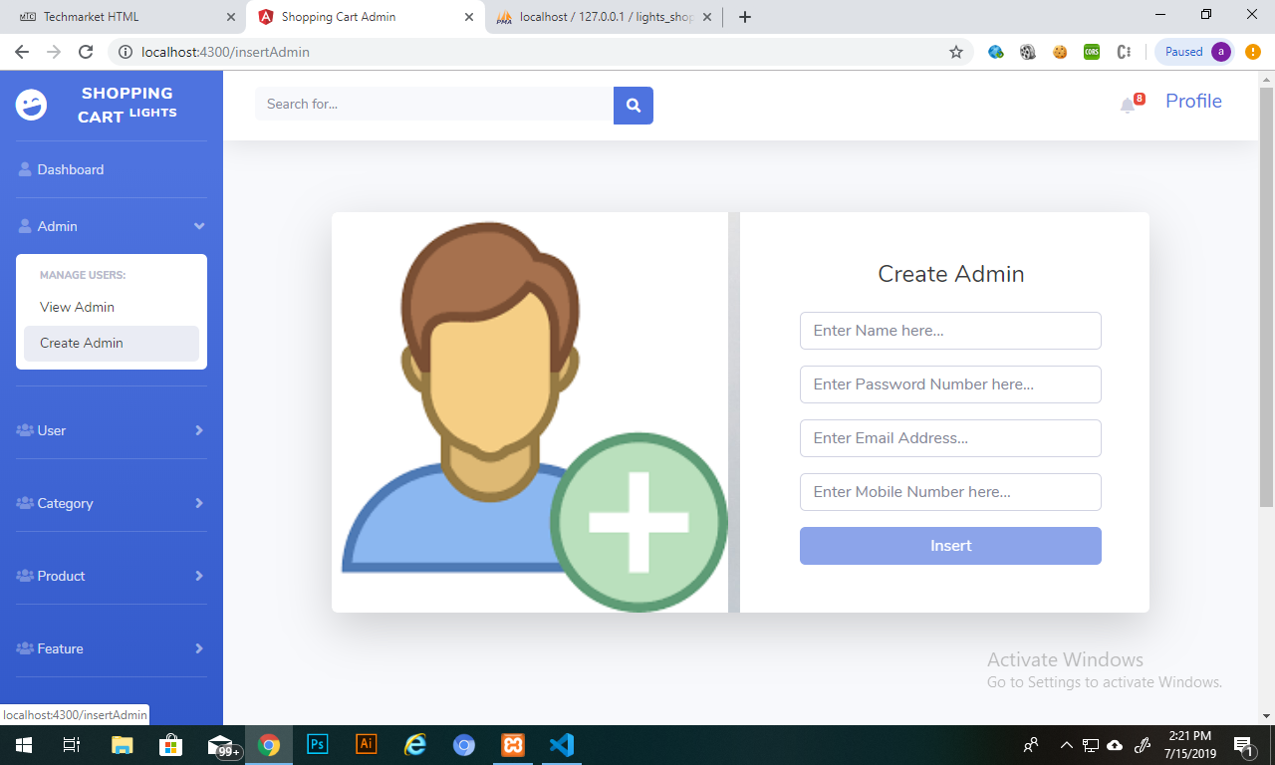

* 1. **System Navigation**

User & Venue Owner

Admin

* 1. **Front End Design**
  2. **Report Design**

**Chapter 5**

**System coding**

**Chapter 6**

**Testing**

* 1. **Test Cases**

Login

|  |  |  |  |  |  |
| --- | --- | --- | --- | --- | --- |
| Test Id | Test Scenario | Description | Excepted result | Actual result | Pass/Fail |
| 1 | Login | Enter valid Username and Password | Successfully Login | As Excepted | Pass |
| 2 | Login | Enter Invalid Username and Valid Password | User should not login to system | As Excepted | Pass |
| 3 | Login | Enter Valid Username and Invalid Password | User should not login to system | As Excepted | Pass |
| 4 | Login | Enter Invalid Username and Password | User should not login to system | As Excepted | Pass |

Registration

|  |  |  |  |  |  |
| --- | --- | --- | --- | --- | --- |
| Test Id | Test Scenario | Description | Excepted result | Actual result | Pass/Fail |
| 1 | Registration | Enter Valid Data | User Should Register to the system | As Excepted | Pass |
| 2 | Registration | If the User is Already exist then New User can not Register again with same Email id and Mobile | User Should Not Register to the System | As Excepted | Pass |
| 3 | Registration | One Venue Owner Register Multiple Venue | Allow to Register | As Excepted | Pass |

My Profile

|  |  |  |  |  |  |
| --- | --- | --- | --- | --- | --- |
| Test Id | Test Scenario | Description | Excepted result | Actual result | Pass/Fail |
| 1 | My Profile | Users are allowed to Edit First name, Last name, Mobile No, Reset Password | User Should Allow to Changes Details | As Excepted | Pass |
| 2 | My Profile | Users are allowed to Deactivate Their Account | User Should Allow to deactivate | As Excepted | Pass |

Booking

|  |  |  |  |  |  |
| --- | --- | --- | --- | --- | --- |
| Test Id | Test Scenario | Description | Excepted result | Actual result | Pass/Fail |
| 1 | Booking | Venue is book and Email is sent to User | Book the venue and send the Email | As Excepted | Pass |
| 2 | Booking | If the Venue is Book already then User cannot Book on the same Date | Cannot Book Venue on same date | As Excepted | Pass |
| 3 | Booking | If the User cancel their Booking then Another User Book that venue on same Date | Other user Should Book that venue | As Excepted | Pass |

My Bookings

|  |  |  |  |  |  |
| --- | --- | --- | --- | --- | --- |
| Test Id | Test Scenario | Description | Excepted result | Actual result | Pass/Fail |
| 1 | My Bookings | User can cancel the Booked Venue | Cancel the Venue | As Excepted | Pass |

Ratings

|  |  |  |  |  |  |
| --- | --- | --- | --- | --- | --- |
| Test Id | Test Scenario | Description | Excepted result | Actual result | Pass/Fail |
| 1 | Ratings | User can give the Rating and Comment on Venue Facilities other User can show the Ratings and Comment | Rating the Venue | As Excepted | Pass |

Inquiry

|  |  |  |  |  |  |
| --- | --- | --- | --- | --- | --- |
| Test Id | Test Scenario | Description | Excepted result | Actual result | Pass/Fail |
| 1 | Inquiry | User can send the Inquiry of anything and will response | Read the Inquiry and send Response | As Excepted | Pass |

**Chapter 7**

**Future scope & Conclusion**

* 1. **(comment)Assumption**
* The system developed by us are useful to our end users to find best place with high amount of facilities without even wandering.
* The venue owner can spread their business more with less efforts through our system.
* All the information of venue provided by owner will be genuine.
* User can sign in with Google and Facebook so that they need not have to fill the registration form. It makes interaction with system easy.
* We provide online payment option which is must in now-a-days.
  1. **(comment)Limitation**
* For initial level we have provided onlylimited cities.
* Venue owners have to fill all the details regarding the venue by their own, and then it will be checked and listed if the information is genuine.
  1. **Conclusion**
* The system will be very useful for the users who don’t want to wander in search of perfect venue for events.
  1. **Future Scope**
* In future we will make a mobile app for our system so that our user can easily operate it from everywhere.
* In future we are planning to give more features to users like, an event management organization, wedding planners, decoration providers, performance artists. They can directly login into our system, so that they can expand their business or services.
* In future we are planning to provide chat support and helpline to our clients so that they can gain expert advice for the events they are going to organize.
* In future we will expand for more cities.